**What is Two-Factor authentication?**

Two-Factor authentication or better known as (2FA) is a standard way to add further protection to a user account or a system. Having a second layer of defense makes it significantly harder for an attacker to gain unauthorized access by requiring the user to provide two sperate forms of identity before being granted access into the account or system.

The basic saying for 2FA is that it is something the user would know, or something the user would have. One of the most common forms of this is having a mobile device with a phone number linked to the account. After logging in, it will send a one time code to your phone and then you will have to put this code into the login to continue. This will stop many attackers, as they have no way of accessing this code.

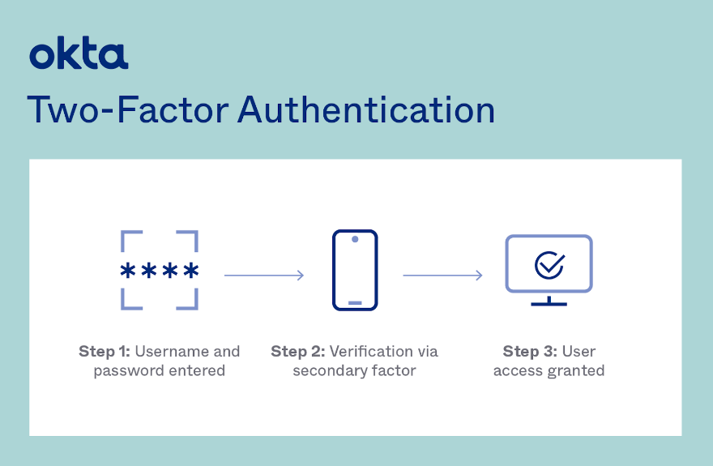

By requesting two different factors, the security of the account is greatly increased as an attacker would first need to know the password for the users account, and then the code sent to an email or a mobile device. Even if an attacker succeeds in stealing the user's password with techniques such as phishing or brute force attacks, it will now be considerably harder for them to access user accounts or systems.

2FA is a quick and extremely effective way to add a second layer of defense that will stop a majority of unauthorized user’s in their tracks. Today, many well-known online services, including Google, Facebook, and Amazon, give their consumers the option of 2FA. The usage of 2FA is also required by many sectors, including finance and healthcare, as a security measure for their online systems and apps. If used effectively in an organization, it can be easy to manage with multiple ways to secure user and system accounts.

“Microsoft.” *Microsoft Support*, https://support.microsoft.com/en-us/account-billing/how-to-use-two-step-verification-with-your-microsoft-account-c7910146-672f-01e9-50a0-93b4585e7eb4.

Shyamsundar, Teju. “What Is Two-Factor Authentication (2FA)? .” *Okta*, Okta Inc., 9 Mar. 2022, https://www.okta.com/blog/2021/07/what-is-two-factor-authentication-2fa/.